A requiem for my wild, witty, lovesome and beautiful wife: It's been three weeks since his beloved Elizabeth died. Here, JONATHAN AITKEN describes the bewildering combination of sorrow and gratitude he feels when people ask how he's coping
By JONATHAN AITKEN FOR THE DAILY MAIL
PUBLISHED: 22:37, 8 May 2022 | UPDATED: 02:13, 9 May 2022

Bereavement, even when expected, hits hard. The passing of my beloved wife Elizabeth has brought an avalanche of turbulent emotions, tears, fears, hopes, challenges and blissfully happy memories.
'How are you coping?' everyone asks. The answer is too deep for words. But at surface level I can truthfully say: 'Much better than expected, because my feelings are only 20 per cent sorrowful and 80 per cent grateful.'
At her funeral on Tuesday, I quoted a line of 17th-century literature. She was 'wild, witty, lovesome, beautiful and young'.
These qualities, long before we met, gave her two movie-star husbands (Richard Harris and Rex Harrison) and a lifestyle which she described in her 1976 memoir as a saga of 'tenderness, treachery, madness, adultery, drink, ambition and suicide'.
But the real Elizabeth — whom I adored for 24 years (18 of them in marriage) — was a far deeper, kinder, more spiritual and family-centred woman with a heart full of love.
By the time I knew her, she had travelled lightyears away from the Rank starlet-turned-Hollywood femme fatale portrayed in the gossip columns of the 1960s.
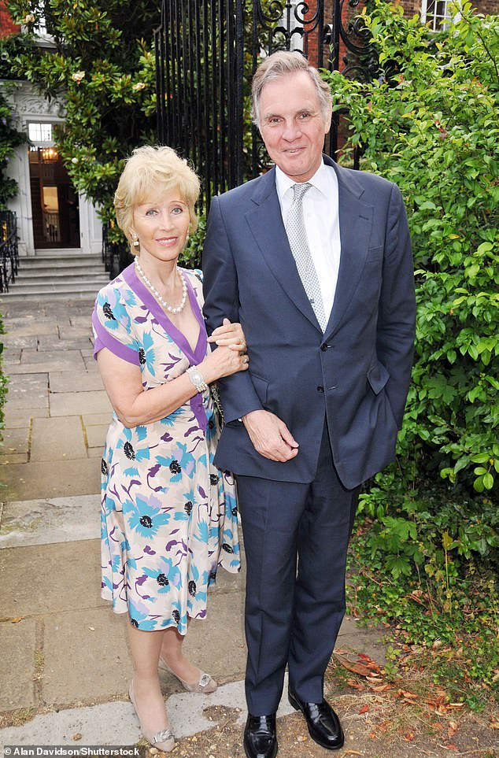

Bereavement, even when expected, hits hard. The passing of my beloved wife Elizabeth has brought an avalanche of turbulent emotions (Jonathan Aitken with Elizabeth in Richmond Park in 2010)
Initially, I had fallen for Elizabeth because she was beautiful, while her wit and spirited approach to life's problems kept both of us young. Yet, as her final years became increasingly dogged by ill health, I found it even easier to love her when she was vulnerable.
About two years ago, when the pandemic was at its height, we were watching a Covid briefing from No 10 Downing Street. One of the Press Conference Prophets of Doom was giving apocalyptic predictions about hundreds upon hundreds of thousands of elderly people who were imminently likely to die from the disease.
Elizabeth sat up in bed and said cheekily: 'The way that man's talking makes it sound as though those of us who aren't already dead must be slacking.'
This was a bittersweet joke because Elizabeth had by then already endured more than her fair share of brushes with death.
They included three dramatic brain surgery operations to repair a bleeding aneurysm and remove two cancer tumours; two strokes; two heart attacks and countless other medical complications. She fought back from them all, though, retaining her speech, spirit and wit to the end.
In fact, I nearly predeceased her a year ago; I had to be rushed off to hospital for high-risk surgery when my colon became poisoned by septicaemia. As I was being carried out of our house, I made a rather pompous farewell speech to her: 'My darling, I'm afraid the next time I see you may be at my funeral.' Quick as a flash, Elizabeth retorted: 'I know just what to wear for it!'
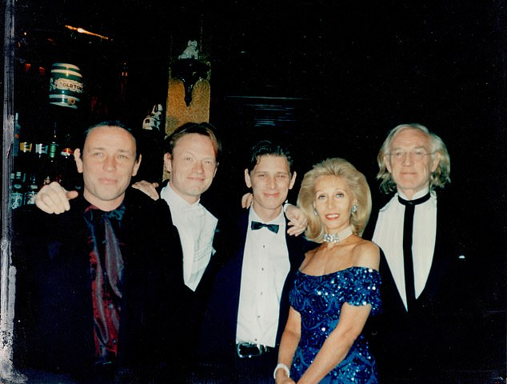

'How are you coping?' everyone asks. The answer is too deep for words (Elizabeth with Richard Harris and sons, from left, Damian, Jared and Jamie)
When Covid came, she was equally as unfazed. Displaying the immunity of a battleship, she never caught the virus, even when I had it twice and one of her carers was hospitalised with it.
Perhaps because Elizabeth had lived through the Blitz and watched the Luftwaffe's bombings of Cardiff Docks from her childhood bedroom window, she was not unduly fearful.
She used to say things like: 'Well, at our age, you have to die of something, haven't you?'
Of course, she took Covid seriously and sympathised greatly with those who suffered or lost loved ones. Indeed, when the pandemic was raging she initiated some deep conversations about her own death and mine.
'Don't you dare go before me,' she would say as she chose the Welsh hymns, the readings and the prayers for her funeral. Preparing for death is a serious business, but Elizabeth managed to do it with touches of levity.
She required end-of-life care for the last phase of her journey. For months she was wonderfully looked after at home by her devoted carer, Jessie, under the supervision of the excellent Trinity Hospice team.
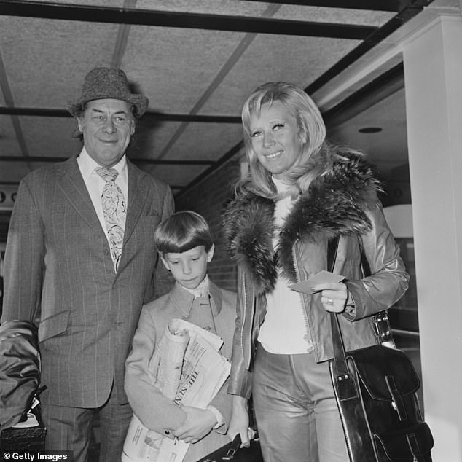

English actor Rex Harrison pictured with his wife Elizabeth Rees-Williams and her son Jamie Harris at Heathrow airport in London as they await a flight to Nice on 2nd October 1972
Elizabeth's last day — Good Friday, April 15 — was peaceful, even joyful. On the morning of her death she woke me up just before 6am by singing!
Her Welsh genes inspired a lifelong love of song, with the slight disadvantage that she could not sing in tune. That morning, she joyfully regaled me with what was just about the only piece in her repertoire — not once, but at least six times:
The sun has got his hat on,
Hip-hip-hip, hooray!
The sun has got his hat on
And he's coming out today.
Miraculously, though, for the first time I can remember, she sang it in tune. In the natural world there are species of birds — sea eagles and swans — who are said to sing only once, just before death. Perhaps Elizabeth knew this was the end.
She had a minor heart attack later that afternoon and was taken into Chelsea and Westminster Hospital. And although she was gradually sinking, she was strong enough to take phone calls from her sons.
I hoped dearly that she might rally yet again — after all, she had fought back so many times from death's door. So I said to her: 'My darling, do you realise you are only 16 days away from your 86th birthday? We are planning a party for you. Your six-month-old great-grandson Marlon will be there to help you blow out the candles.
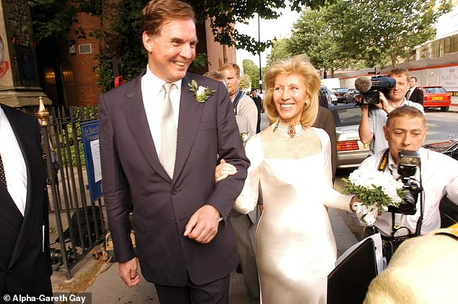
Initially, I had fallen for Elizabeth because she was beautiful, while her wit and spirited approach to life's problems kept both of us young (the couple on their wedding day in June 2003)
'Do you think you can fight back again and get to your party on May 1?' Elizabeth gave a gorgeous smile and whispered: 'You bet!' Those were her last words to me.
I shed many tears before having to enter the grisly world of bereavement bureaucracy: visits to the mortuary; Cause of Death Certificates; financial protocols; arrangements with undertakers — these are the obligations that only a next of kin can fulfil.
But gradually my load — and my grief — lifted as Elizabeth's sons flew in from their various filming locations. Damian (director) from New York; Jamie (actor) from LA and Jared (actor) from Prague.
We are a close family sharing a deep love for Mum/Elizabeth. And arranging the funeral itself was relatively easy because she and I had planned it together in advance with the vicar and the musical director of St Matthew's Westminster — the church where we were married in 2003 and where I serve as an assistant priest when I am not on duty as a prison chaplain.
St Matthew's gave Elizabeth a magnificent send-off, touching sublime heights of musical, spiritual and prayerful excellence. And my grief, great though it remains, is transcended by gratitude.
One of my favourite gems of spiritual wisdom is in a book written by 17th-century theologian William Law, titled A Serious Call To A Devout And Holy Life. It says: 'If anyone would tell you the shortest, surest way to all happiness, he must tell you to make it a rule to yourself to thank and praise God for everything that happens to you.
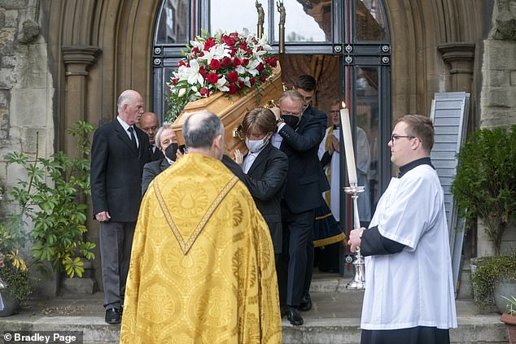
At her funeral on Tuesday, I quoted a line of 17th-century literature. She was 'wild, witty, lovesome, beautiful and young' (Elizabeth's funeral)
'For it is certain that whatever seeming calamity befalls you, if you thank and praise God for it you turn it into a blessing.'
Although in her wilder years Elizabeth had a Calamity Jane streak in her, she was a God-given blessing to me and her family. That's why it's so easy to give thanks for her and her qualities. In addition to being 'wild, witty, lovesome, beautiful and young' she was mightily courageous. Through all the changing scenes of her colourful life she consistently displayed a wintry bravery, not least during her final years of debilitating illness.
Although it sometimes suited her to play the dizzy blonde, in fact she was hard-working, efficient and competent. She ran her own successful PR business for many years. She was steady in any crisis. When her first of four husbands, Richard Harris, died 20 years ago, he showed his great trust in his ex-wife by making her the sole executor of his will.
The way she tackled the complicated challenges of her legal duties, seeing off expensive law firms in three jurisdictions, defeating spurious claimants and fighting like a tigress to preserve her sons' inheritance, was one of her finest hours.
She was often unconventional in her thinking, too. For example, her attitudes to gender issues were original. She had no time for feminism because she believed that women already had the upper hand, so why upset the apple cart? But above all, Elizabeth was matriarchal. That is a rather grand way of saying that she loved her family and was at her happiest when surrounded by them.
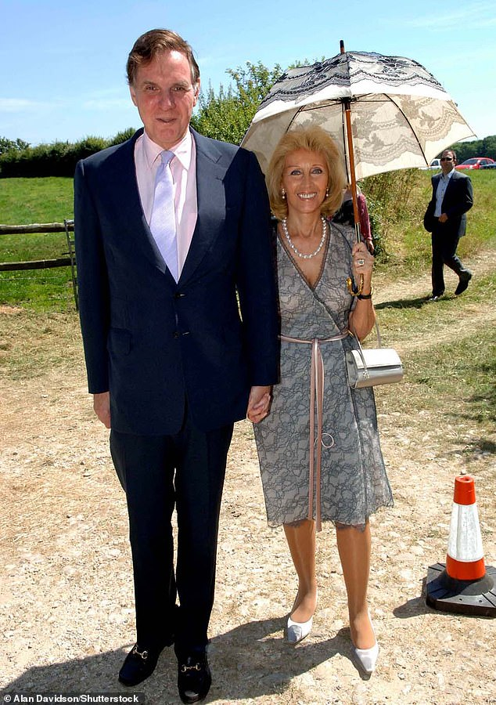

Jonathan and Elizabeth pictured at a wedding at St Michael and All Angels Steeple in Dorset in 2005
Motherly, grandmotherly and, in recent months, great-grandmotherly love poured out of her.
At her funeral, her sons gave a combined filial tribute — a powerful and emotional portrait of Mum the lynchpin, the counsellor, the homemaker. They described how she held the family together through dramas, upheavals, break-ups, house moves, divorces, emotional troubles, financial woes, medical concerns — you name it, the Harris boys had come up against it.
But with Elizabeth, there was always laughter somewhere in among the turmoil. As Jared put it: 'You had to have a sense of humour when your mother sends you to a very conservative boarding school and turns up at sports day dressed like Raquel Welch in One Million Years B.C. Of course, this made you very popular with the other boys.
'So did backing Rex's Rolls-Royce into the science building. She took out an entire corner, leaving a huge hole. All our chemistry classes were cancelled until they could rebuild the building. That made us even more popular!'
Elizabeth also reached out in a motherly way to those outside her family who were down on their luck or going through a bad patch.
She had a heart for ex-offenders who often came to our home. One of them was my cell neighbour when I was in Belmarsh prison, Leroy Skeete. She was fond of Leroy, knew him well and helped him to find his feet after his release.
Last week, Leroy wrote me a touching letter of condolence saying that, because he had been rejected by his birth mother, he had come to think of Elizabeth as a parent. She would have loved that.
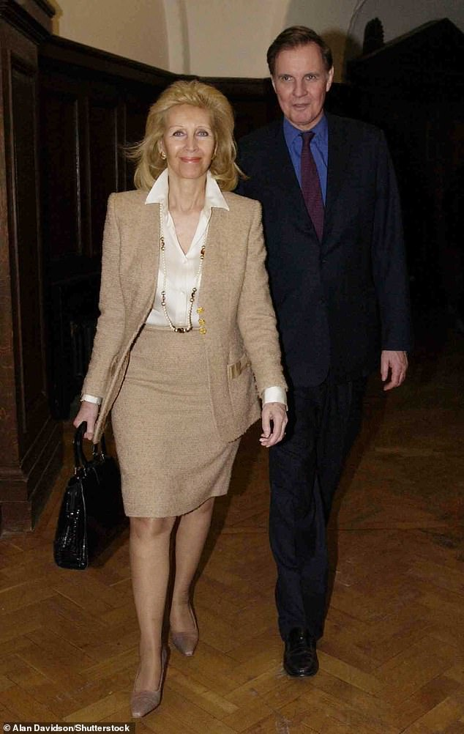
Jonathan and Elizabeth at The New Saatchi Gallery Opening Night Party at County Hall London in 2003

So as a matriarch in the widest sense, she would have been pleased that the pallbearers at her funeral consisted of her sons, a grandson, a nephew — and Leroy.
If I am ever to be given a medal, perhaps it might bear the inscription: 'Elizabeth's longest-serving husband.'
But truly she is the one who deserves the medal. For she was such a wonderfully loving and supportive wife.
Without her strong and prayerful support, I would not have become ordained as a priest and prison chaplain. Without her encouragement, I'd not have written 12 books during our marriage — all of them dedicated to her.
Perhaps our greatest blessing as a couple is that we shared in the gift of a strong and committed faith. Elizabeth had no fear of death. As she left this world, peacefully, painlessly and surrounded by love, we were both confident that we will be reunited again.
That's why my last words to her, spoken at the end of my tribute at her funeral, were: 'Thank you for everything my darling Elizabeth — and au revoir.'

