Ex-con Jonathan Aitken to be prison chaplain
Laura Pullman
June 3 2018, 12:01am, The Sunday Times

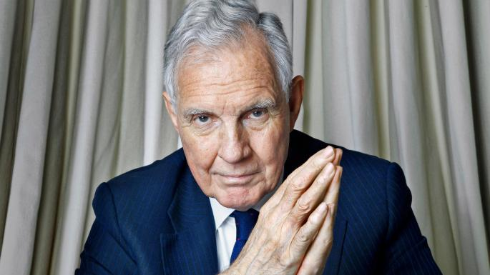

The former Tory cabinet minister became serious about religion while jailed for perjury in 1999 TOM STOCKILL
Since the prison gates clanged shut on him nearly 20 years ago, Jonathan Aitken has been on a pilgrimage of self-discovery. Now the former Tory cabinet minister has reached a destination: he is going to be ordained at St Paul’s Cathedral by the first female Bishop of London, Dame Sarah Mullally.
After “being given the sacred trust”, he plans to work as an unpaid prison chaplain for three or four days a week, mostly in jails around London.
In an interview with The Sunday Times, Aitken, 75, describes the step as a “life-changer” and says: “I’m every bit as excited as I was on my first day on the East Anglian Daily Times as the assistant tennis and funerals correspondent.”
He became serious about religion while serving a prison sentence for perjury in 1999 after lying on oath in a libel case against The Guardian. He has described persuading his then teenage daughter Victoria to give him a false alibi as his “most shameful mistake”. He also lied about who paid for his £1,000 hotel bill at the Ritz in Paris.
The solitude of the cells provided a perfect place for contemplation. Aitken joined a prayer group that included “an armed robber, a blower (someone who cracks safes), a kiter (a cheque forger), a couple of murderers and a dipper (a pickpocket)”.
After his release he studied theology and considered trying to join the church. “Though, 18 years ago, I think if they’d had any sense the Church of England would have rejected me. Remember what a hot potato I was — going through this downward spiral of defeat, disgrace, divorce, bankruptcy and jail — so I don’t think they’d have been queuing up to have me as a curate.”
Invitations for his ordination on June 30 are yet to go out but Aitken says that former parliamentary colleagues and ex-prisoners will be there along with his wife, Elizabeth, 82, and at least three of his four children. He added: “I live in a more real world now and am very happy with it.”

