THE SPECTATOR

Christmas tales from the prison pulpit
Patrick Kidd
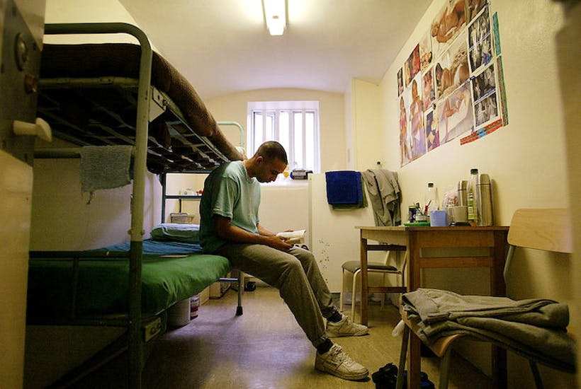
Patrick Kidd
28 December 2019
12:28 PM
It was an unusual Christmas morning chapel service. There was a bishop, for a start, and a baptism and then, somewhere between the peace and the eucharist, two of the congregation started trying to thump each other. Boxing day, it seemed, had come early.
‘It unnerved the bishop slightly,’ the priest in charge admits, ‘but as these things go it was a very mild flurry of fisticuffs. Punches were thrown but none landed.’
The Bishop of Kensington, paying a Christmas Day visit to HMP Pentonville, may not be used to this sort of laying on of hands during the liturgy but for the Rev Jonathan Aitken, now six months into his new career as a prison chaplain, it was business as normal.
Exactly twenty years ago the former cabinet minister was the other side of the bars, nearing the end of a jail sentence for perjury. He had been moved three days after Christmas to complete his term in a higher-security prison after wardens had uncovered a plot by inmates to drug Aitken with Rohypnol, put him in bed with a nude inmate and sell the photos to a tabloid.
Now Aitken, 77, who was ordained in June, is in the middle of an unbroken ten-day stretch at Pentonville over the festive period. He spent the day before Christmas making a list and checking it twice, less to find out who was naughty or nice, since the courts had already decided that, but to see who needed watching or special care at this time.
‘Christmas is potentially a dangerous time in prison,’ he says. ‘Spirits plummet and many prisoners feel especially alone and unloved. A lot of intelligence is compiled on their moods. It’s impressive how much trouble the prison takes to brief us thoroughly.’
His appraisal when we spoke after the Boxing Day shift was that it had so far been ‘surprisingly quiet’, though he admits that ‘prison officers say the word “quiet” with the same caution as actors say “Macbeth”.’
Most of his Christmas and New Year duty will be spent wandering the corridors, doing what Jo Davies, the senior chaplain at Pentonville, calls ‘loitering with intent’, discovering who is emotionally fragile and in need of someone to talk to or pray with.
‘The dog collar is strangely popular in prison,’ Aitken says. The arrival of the ‘pie’ (prison slang: pie and liquor = vicar) is usually welcomed. Having been where they are, if not in quite the same situation as the recently sentenced murderer with whom Aitken had a long chat on Boxing Day, he speaks their language.
His Christmas season had begun this year on the substance-abuse wing of HMP Brixton, attending a carol service for the Forward Trust rehabilitation charity. As the congregation began with O Come, All Ye Faithful a tattooed robber burst into loud sobs.
Aitken hugged him and asked if he had received a recent setback. ‘No, mate, I’m crying with happiness,’ the prisoner replied. ‘I’ve been doing literacy classes and for the first time in me life, I can read the bleeding words.’
Aitken may have passed his own time in prison learning New Testament Greek and reading political biographies, but a third of inmates struggle with basic English. Illiteracy is the greatest barrier to rehabilitation. Aitken also supports efforts to better educate wardens. In France, training of prison officers lasts almost a year; in Scandinavia it takes two to three. In Britain, the standard training period is only three months but in 2017 a new scheme called Unlocked Graduates, modelled on the inner-city Teach First programme, was introduced to attract prison officers with a degree. This year there were 15 applicants for every place.
Existing officers are also being encouraged to improve their education. Aitken was delighted to speak on Christmas Day to a senior Pentonville officer called Noel Young, who ironically had been the admissions officer when he began his sentence at Belmarsh in 1999. Beaming with pride, Young told him that he has just won a scholarship, at the age of 51, to read a criminology degree at Cambridge and write a thesis on self-harming by men in prison.
Old Etonian, Old Belmarshian, minister in both senses of the word, Aitken lives in two worlds. On the night of Christmas Eve, he went to a party of literati held by Antonia Fraser before reading the Gospel at a high Midnight Mass at St Matthew’s, Westminster. After four hours of sleep, he rose to drive across London to go through the security rigmarole to get into prison.
There he found Prison Officer Patterson ‘full of the Christmas spirit’. As they walked together into the prison yard, she suddenly threw back her head and sang Hark the Herald Angels Sing with all the verve you would expect from someone who leads a gospel choir in her spare time.
In the chapel, Aitken met Davies and the bishop, Graham Tomlin, who had been his tutor at Wycliffe Hall, Oxford, where Aitken studied theology after his release, as well as 25 volunteers from local churches who assist with pastoral care. As cells were unlocked and 100 prisoners arrived for the 9.30am service, Aitken shook their hands at the door, in greeting but also to make a note of those troubled souls who would need a private chat later.
‘There was a bittersweet feeling,’ Aitken says. ‘One or two of them were really looking down, even tearful. More were just subdued.’ As the service went on, though, with Silent Night and O Little Town of Bethlehem, they began to forget their cares.
By the time they reached the baptism of a remand prisoner from the Congo, who was drenched by the bishop over the sort of tin tub you could dip a sheep in, the congregation had really come to life. At the conclusion of While Shepherds Watched, one shouted: ‘Let’s sing it again.’
It demonstrated how prison, though of course it exists to punish, should not write off failed lives as beyond redemption. ‘Pentonville’s Victorian infrastructure is out of a Dickens novel,’ Aitken says, ‘but the outstanding attitude of its staff and their desire to help prisoners to turn their lives around shows the spirit of Christmas future.’
Patrick Kidd is a writer for the Times and the author of ‘The Weak are a Long Time in Politics: Sketches from the Brexit Neverendum’.

