Jonathan Aitken completes path from perjury to the priesthood
Patrick Kidd
July 20 2019, 12:01am, The Times

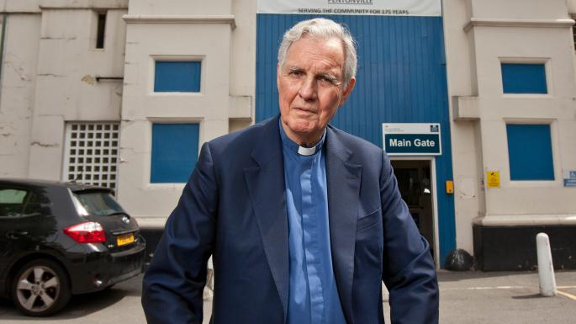

Once a cabinet minister, Father Jonathan Aitken is preaching in prisons 20 years after he left jail

BEN GURR FOR THE TIMES
The scenes for the newly ordained priest’s first and second Masses could not have been more different. The first, last Friday night in Westminster, was higher than Rome: all bells, smells and lashings of Handel, with members of the aristocracy in the congregation.
The second, 39 hours later in north London, was low church, evangelical, tracksuits and trainers. The priest wore blue, since a black shirt traditionally meant a hanging, and had a whistle round his neck in case of trouble. And yet he felt at home in each. Father Jonathan Aitken belonged to both flocks.
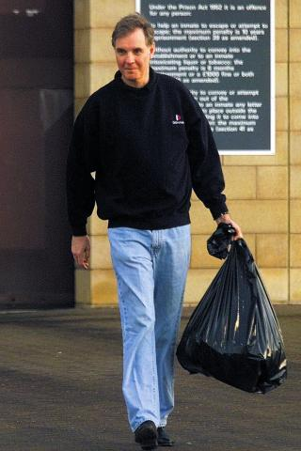

Mr Aitken was sentenced to 18 months for perjury in Belmarsh in 1999 REUTERS
As he told the congregation at Pentonville prison in his first sermon since becoming a priest, he was a fellow lag. “Twenty years ago this month I started my own prison sentence in Belmarsh,” he said. A whisper spread. Belmarsh? Respect! “Yeah, a much tougher nick than here,” Mr Aitken told them.
He survived, he said, because of the experience picked up doing some “previous” at HMP Westminster, as an MP for 23 years before he was sentenced to 18 months for perjury. He helped inmates with their letters home. Apparently, the women of south London had never read such poetry.
The path from Old Etonian to Old Belmarshian and then to the clergy was not the one that Mr Aitken had set out on. His fall was humiliating but also a chance to reboot his life. When he was jailed in 1999 he recalled seeing “a panorama of anger and despair”. And this from a man who had been in John Major’s cabinet.
As we chatted before his first Mass in Westminster, the choir was rehearsing All We Like Sheep Have Gone Astray. A suitable tune and not just because he had sung it as a choirboy at Norwich Cathedral in 1952. After his release Mr Aitken studied theology at Wycliffe Hall in Oxford, “the only institution with worse food and more uncomfortable beds than prison”. This was just an academic interest, however. It was four years ago that he got “the call”. As he prayed, he felt a voice telling him to seek ordination, though he was then 72, and work as a prison chaplain.
So began the path that took him to Pentonville. On his first day as a curate, a year ago, the duty governor said: “We’ve met before.” He had been the admissions officer the night that Mr Aitken came to Belmarsh.
A year later he was a priest, able to celebrate communion. One in ten prisoners attends church and while some, he concedes, do it to pass notes, most seek comfort. “Hope is a commodity in very low supply in prison,” he said.
He has struck up a friendship there with Imam Tayib Ali, the Muslim chaplain, bonding after finding that Mr Ali came from the Sudan, where Mr Aitken’s grandfather had been governor-general. Mr Ali invited him to a service last year and halfway through, without warning, asked him to say some words.

The priest gave a second Mass to a congregation at Pentonville prison ANTHONY DEVLIN/PA
“It was a shock but I know some Arabic and can do greetings,” he said. “Then something tumbled from the attic of my memory: the only verse in the Koran I know, which is that paradise lies at the feet of mothers.” He told them this and recalled the difficulty he had when his mother, then 92, visited him in jail. “She would choke up, I would choke up and by the end, after I had told the inmates that they should all behave the way their mothers would like them to, the whole room was choked up.”
Many will not forgive him his past. In a statement after he was sentenced for what the judge called “a web of deceit” he said: “This is a burden I will have to bear for the rest of my life.” Others may feel that his actions since prison show redemption. Mr Aitken describes his career as “decades of climbing downwards and falling upwards”.
There was a moment just before Mass in Westminster that seemed apt as the silence of the congregation was broken by a late arrival whose satnav loudly declared: “You have reached your final destination.” It was not the route Mr Aitken had set out on, but he is happy with where it brought him.

