UNITE

Linking Christians; introducing people to JESUS!

An evening with
JONATHAN AITKEN
6.30pm Wednesday, 15th March
Longton Central Hall, Stoke-on-Trent ST3 2JH

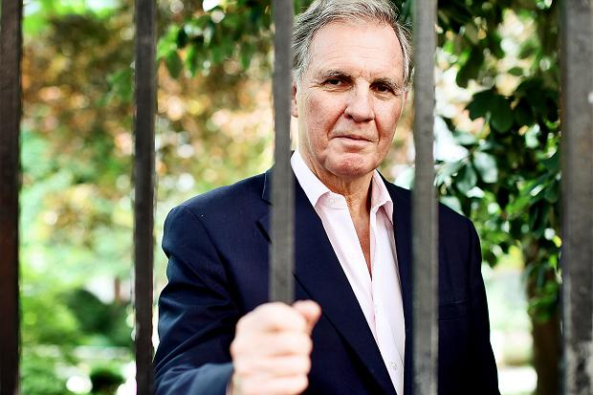

Jonathan Aitken was a Member of Parliament for 24 years, and a Cabinet minister. He was convicted of perjury in 1999 and received an 18-month prison sentence. Following this he met with Jesus and his life was changed!! Since then Jonathan has spent much of his time ministering in prisons throughout the world. He is currently president of
Christian Solidarity Worldwide.

Jonathan will be speaking shortly after 6.30pm. Following this, there will be worship, an opportunity for people to share their own Christian testimony.

Free event. Free refreshments. All welcome.

Cedric & Jean Barber www.christiansunite.org.uk 07815 830123 je_ce_barber@hotmail.co.uk

